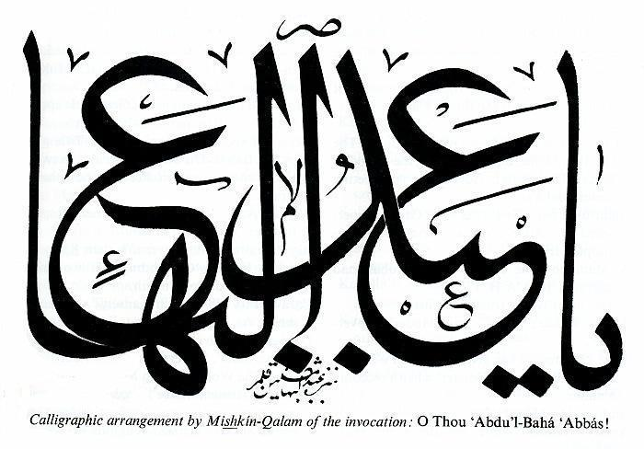

Contents
2. Words of Abdu’l-Baha
3. Abdu’l-Baha
4. Abdu’l-Baha and Japan
6. Words of Abdul-Baha
7. Okinawan Children
9. Quiz
10. Coloring Page
11. Photos of Winter School
12. Virtue Eggs
13. Parents’ Page

Hiru no Hoshi

No. 233

“Ye live
all of you,
Within the heart
of
Abdu’l-Baha”
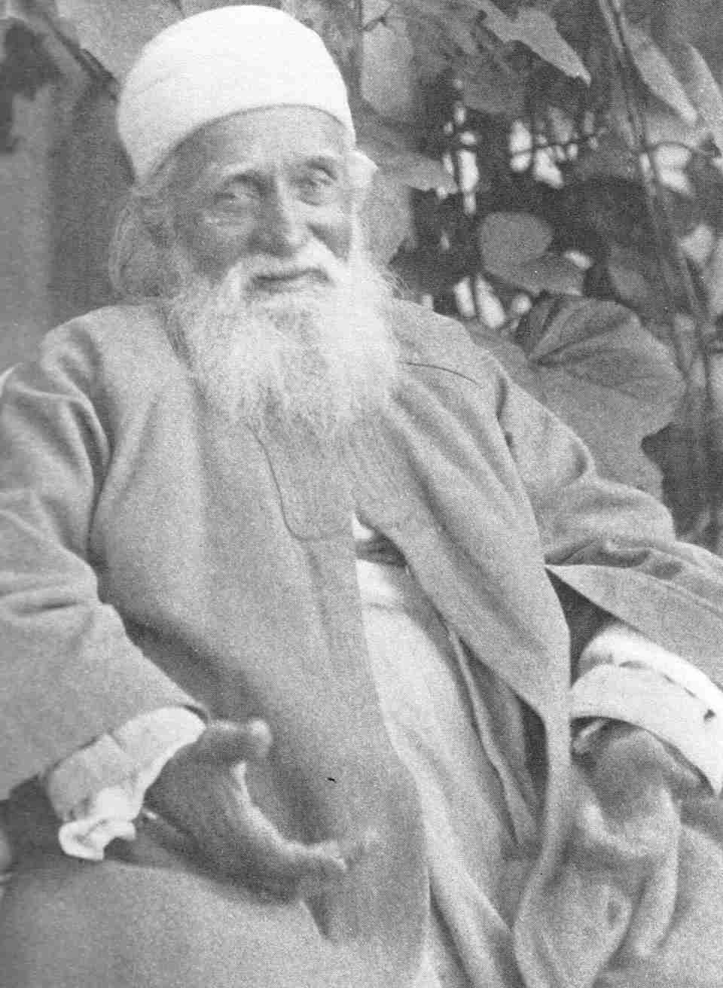
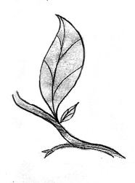
Abdu’l-Baha

As we studied earlier in Hiru no Hoshi, every age, God sends Great Teachers to guide mankind and to teach us what we need to know so that we can become happy and make a wonderful world. In this Day, God sent us Baha’u’llah as our Great Teacher, and Baha’u’llah gave us Abdu’l-Baha to show us and help us understand all the wonderful new teachings that Baha’u’llah brought.
Abdu’l-Baha was Baha’u’llah’s oldest son. Baha’u’llah told us that Abdu’l-Baha was the Center of the Covenant. Covenant means a promise. It is the promise that God will not leave man alone.
Baha’u’llah called Abdu’l-Baha the Mystery of God, because there has never been anyone like Abdu’l-Baha. Abdu’l-Baha was the servant of everyone, He spent His life feeding the poor and helping the sick. Adu’l-Baha was always thinking of the comfort of other people and never of Himself.
When we read the stories from the life of Abdu’l-Baha we learn how to treat other people, always with love and kindness. Abdu’l-Baha shows us that the only way to be happy is to always think about what will make the people around us happy and try and serve every person, even people we don’t know.
Baha’u’llah said that we could be a “new race of men”, people better and nobler that there has ever been on this earth. And He left us Abdu’l-Baha to show us how to be like that.
Baha’u’llah said this about Abdu’l-Baha. “We have made Thee a shelter for all mankind, a shield unto all who are in heaven and on earth.”
Abdu’l-Baha especially loved children, and He loves each one of you. You are all in the heart of Abdu’l-Baha.

Abdu’l-Baha and Japan
Perhaps you have heard stories of the loving and generous words and deeds of Abdu’l-Baha in Israel, London, Paris and America. How He showed the people of every land how to treat each other with love and kindness. But, did you know that Abdu’l-Baha had a special connection with Japan and the Japanese people?
A hundred years ago Kanichi Yamamoto wrote Abdu’l-Baha a letter in Japanese, and although Abdu’l- Baha didn’t know Japanese He understood the words of the heart, and sent Mr. Yamamoto a beautiful letter in reply. Mr. Yamamoto was very happy and grateful to receive Abdu’l-Baha’s wonderful letter. Abdu’l-Baha told Mr. Yamamoto that he “….must warble like the nightingale of significance in the rose garden so that thou mayest inspire all the birds of the meadow to chant and to sing.” The nightingale sings more beautifully than any other bird, Abdu’l-Baha was telling Mr. Yamamoto to tell everyone about the beautiful teachings of Baha’u’llah so they could tell other people too. Mr. Yamamoto was the very first Japanese person to recognize Baha’u’llah, God’s new Teacher to Mankind.
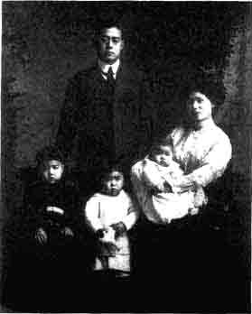

In 1912 when Abdu’l-Baha was visiting America, there was a young Japanese student named Saichiro Fujita who had heard of Abdu’l-Baha and wanted very much to meet Him. When Fujita san found Him, Abdu’l-Baha talked with Fujita san and taught him many things. They became very close friends. Fujita san wanted to follow Abdu’l-Baha wherever He went, and traveled many places in America with Abdu’l- Baha. When Abdu’l-Baha went back to Israel He told Fujita san to stay in America and finish College and learn all he could about electricity and other things so he could come to the Holy Land (Israel) and help Him. So Fuita san did just that. After he finished college he went to Israel and stayed and helped Abdu’l-Baha and the Baha’is until he was a very old man. Fujita san met the visitors from all over the world and showered them with his love and gentleness. There are many people all around the world who remember Fujita san with love and respect. Fujita san and Yamamoto san were both from Yamaguchi Prefecture.
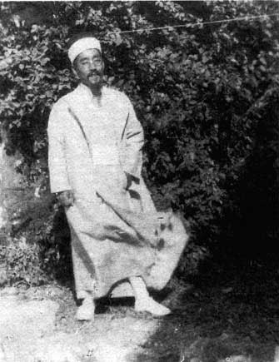
While Abdu’l-Baha was visiting Paris around 1912, the Japanese Ambassador to Spain and his wife very much wanted to meet Abdul-Baha. On the evening of the arranged meeting, though, the Ambassador’s wife became sick with a bad cold, and they could not visit Abdu’l-Baha because it was raining and cold out. Abdu’l-Baha, instead, went out in the rain and cold to visit them. During His visit with them, He told them that“There is in existence a stupendous force, as yet, happily undiscovered by man. Let us supplicate God, the Beloved, that this force be not discovered by science until spiritual civilization shall dominate the human mind. In the hands of men of lower nature, this power would be able to destroy the whole earth.” (Compilations, Japan Will Turn Ablaze, p. 51) Abdu’l-Baha was saying that there is a great power in science that can destroy the whole world and that He hoped mankind would become more spiritual and better people before they discovered this power. Was Abdu’l-Baha warning the Japanese Ambassador about the atomic bomb 30 years before its existence?
Abdu’l-Baha also talked to many other famous and important Japanese people almost a hundred years ago. Abdu’l-Baha explained to all of them how special Japan was. He said “Japan hath made wonderful progress in material civilization, but she will become perfect when she also becometh spiritually developed and the power of the Kingdom becometh manifest in her.” (Abdu'l-Baha, Tablets of Abdu'l-Baha v3, p. 564)
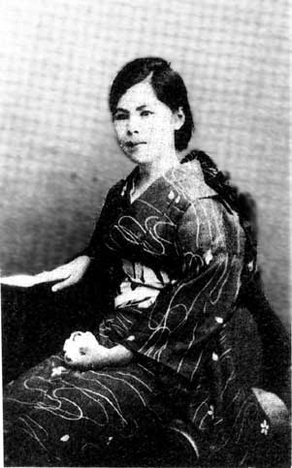
Yuri Mochizuki
the first Japanese woman
to become a Bahá'í.
Let us show Abdu’l-Baha we can help make Japan perfect!

Words of Abdu’l-Baha
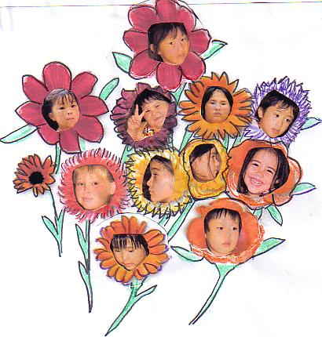

“If you meet those of different race and color from yourself…be glad and show them kindness . Think of them as different colored roses growing in the beautiful garden of humanity, and rejoice to be among them.”

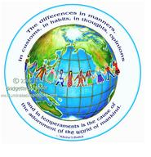
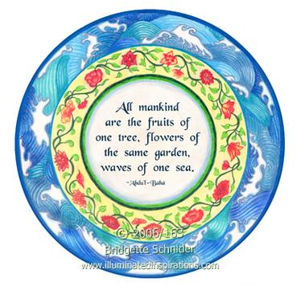
"May you become as the waves of one sea, stars of the same heaven, fruits adorning the same tree, roses of one garden in order that through you the oneness of humanity may establish its temple in the world of mankind."

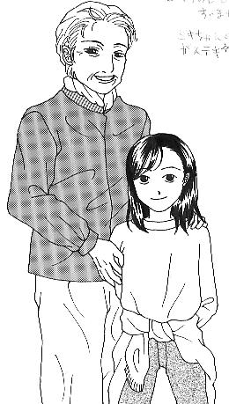
“Care for the stranger as for one of your own; show to alien souls the same loving –kindness ye bestow upon your faithful friends.”

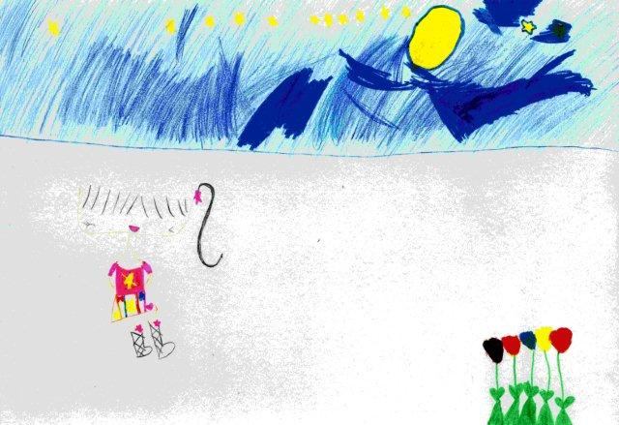

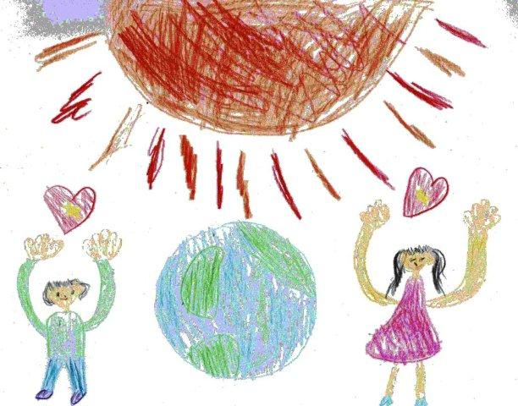

“God has crowned you with honour and in your hearts has He set a radiant star; verily the light thereof shall brighten the whole world.”
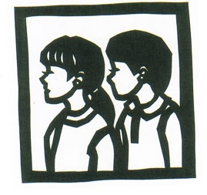 Abdu’l-Baha its Center?
Once Upon a Time in Okinawa, there were 5 little children. One day, Shahla asked Mother, “Mommy, what does it mean that Abdu’l-Baha is the Center of the Covenant. What does ‘Covenant’ mean and how is
Mother smiled and thought a minute, then said, “When I was a little girl, I went to Sunday School Classes and we heard a wonderful story from the Bible about Noah’s Ark. Maybe this story can answer your questions.” The other children heard the word “story” and gathered around to listen. They all loved stories. Little Anisa sat on Mother’s lap, as she began.
“Long, long ago, the people were becoming very bad. They would hurt and kill each other. Everyone was only thinking of themselves and not helping anyone else. God was very sad and He sent Noah to try and teach the people how to be good. No one would listen to Him, so God told Noah to build an Ark, a great, big, boat, because God was going to send a flood. He told Noah that after the Ark was build to take all the different kinds of animals in it, one male and one female (boy and girl). At first Noah didn’t want to do this, it was such a big job, He didn’t think He could do it. But God told Him to try and God would help Him. Well, Noah worked really hard and built the Ark. People would come and laughed at Him, building such a big boat and no water anywhere around. Noah tried to warn the people that God was going to send lots of rain and a big flood was coming, but no one would listen to Him. Finally, the Ark was finished, and all the animals came on board. The cats, and rats and elephants, the lions and tigers and all the birds all the different animals of the world, but only 2 each, male and female, got on the boat. Noah’s wife and sons and their wives got on the Ark, but no one else would get on. Then suddenly, the rains came and the floods came and all the very bad people were swept away. And the Ark floated on the water many, many days until finally God landed the Ark safely on a hill and all the animals and Noah’s family got off the Ark and were safe.”
Then mother smiled. “The meaning of this story is that every time a New Teacher comes to help mankind be better people, it is like that Ark. The Ark is like the laws and teachings of God. Whoever obeys God’s teachings are like the animals that got on that Ark and were safe. And even though the animals are all so different, on the Ark of God, they were all safe together. Just like all the different people of the world, when they follow God’s teaching, they can live happily together. The people that don’t obey Gods laws, are fighting and killing and hurting each other, like people drowning in the waters of their own greed and selfishness. ”
Little Anisa jumped up and said, “And the bad people are like the unicorns!” Asma and Riaz laughed so hard they fell over and rolled on the tatami.
“What do unicorns have to do with anything??” They laughed.
Mona, the oldest scolded her little brothers, “Don’t laugh at Anisa, you will make her cry!”
Anisa stuck her tongue out at her brothers, “Are there any unicorns now, smarties? NO! because they didn’t get on the Ark, they were playing instead, and they didn’t listen to Noah when He said ‘Get on!’ So that’s why there aren’t any unicorns!”
Everyone laughed at that. Then mother finished her story by saying, “ The Covenant is just like that Ark, and Baha’ullah left Abdu’l-Baha to take care of all of us on that Ark, just like talking care of the animals on the Ark so they live loving in peace together. So He is the Center of the “Covenant”, or “Promise” from God.
Shahla stood up and said “That was a good story Mom, I have to think up another question, so we can have another story!”

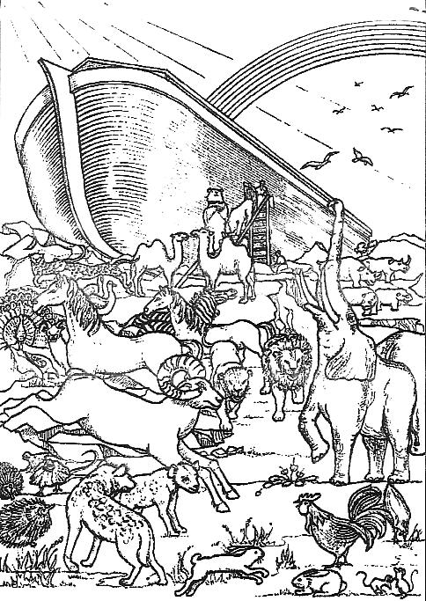
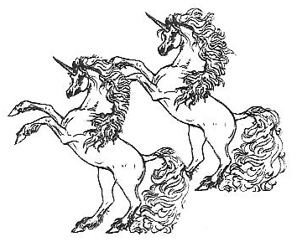

“O Compassionate God, Thanks be to Thee….Thou hast shown me the right way, and caused me to enter the Ark of Deliverance.”
Abdu’l-Baha

Quiz
- Who lives in the Heart of Abdu’l-Baha?

- Who is Abdu’l-Baha the son of?

- Which is a country that Abdu’l-Baha had a special connection with?

- What is the name of the Japanese man that lived with Abdu’l Baha in Israel and helped Him in many ways?

- What did Abdu’l-Baha tell the Japanese Ambassador and his wife?

- What did Abdu’l-Baha say we should do when we meet people of a different color?

- How did Abdu’l-Baha say we should treat strangers?

- In the story of the Okinawan children, what did Mother say the Ark was like?

- Why did they all laugh at Anisa, the little one?

How did you do? Did you get them all right?
The answers are on the Parents Page.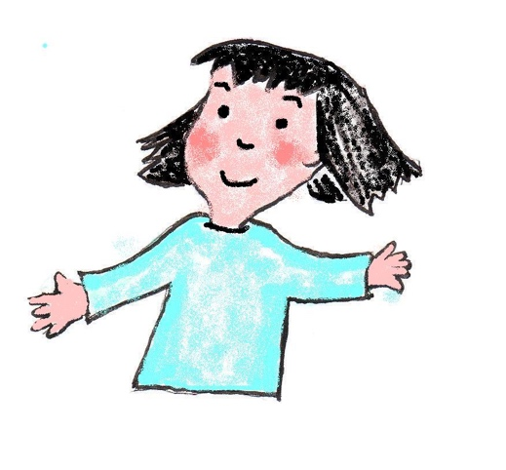

a to b,
b to c,
follow the dots,
and what can you see?
Now color it nicely.
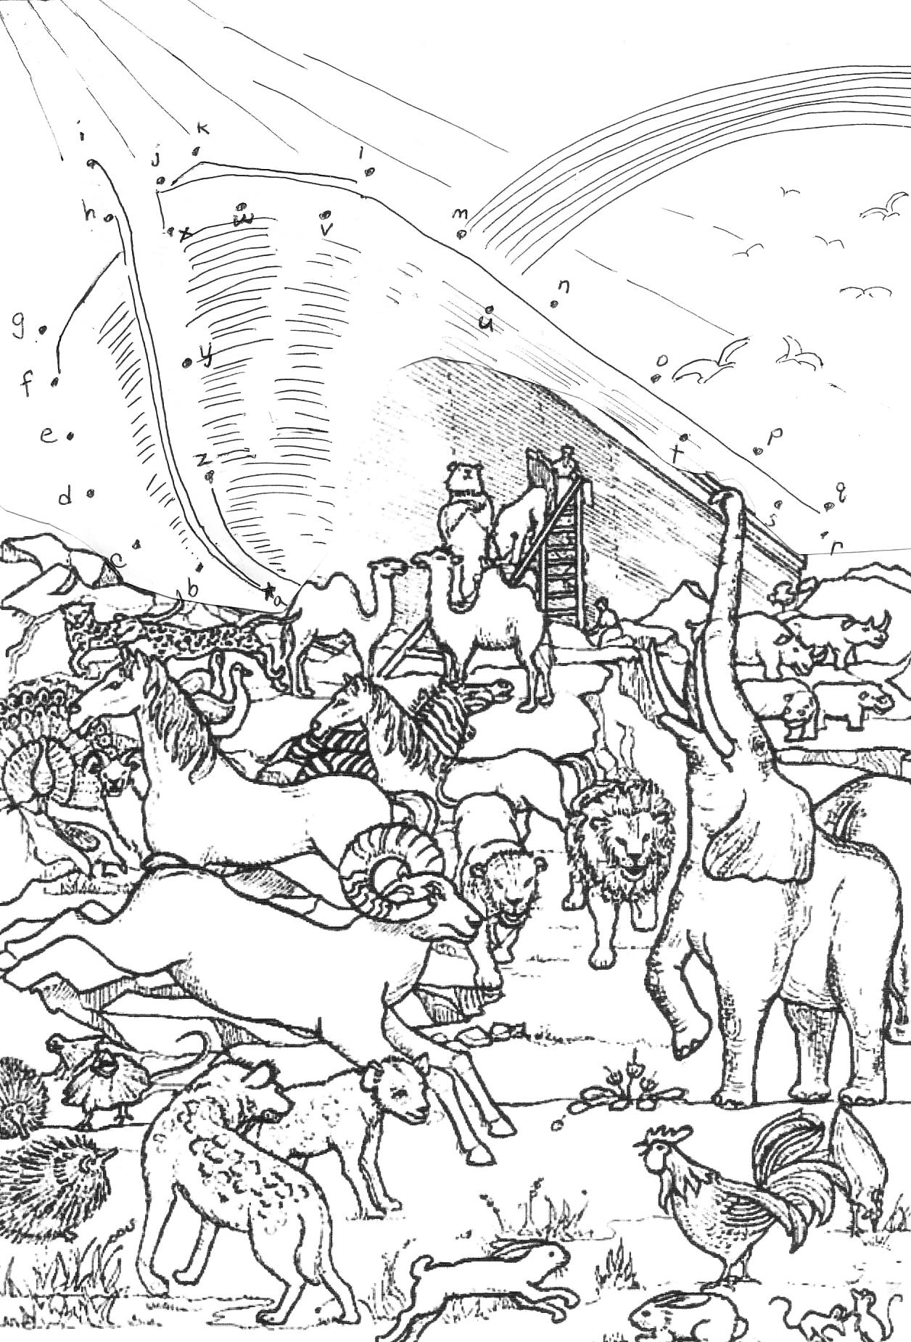

WINTER SCHOOL KIDS

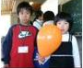

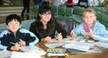
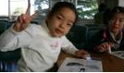
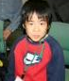

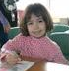
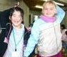

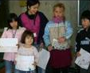

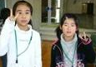

VIRTUE EGGS
During the month of March is when the grown up Baha’is Fast. Children can not fast, but they can help by each day hanging a virtue egg up to remind us all of how we are trying to be better people. At the end of the Fast you would have 19 beautiful Virtue Eggs hanging up to celebrate Naw Ruz, The New Year!
How to Make Virtue Eggs.
- Poke a hole in each end of an egg and blow the contents of the egg into a bowl…..then your mother can cook the egg anyway she wants.
- Rinse the egg carefully and blow out the excess water.
- Get a white crayon or a candle and write a virtue on it….Love, Kindness, Purity, Forgiveness, (look on the Parent’s Page for lots of virtues)
- After you have 19 eggs, put different food coloring in several small bowls with water and 1 tsp. of vinegar. Only fill the bowls half full!
- Put the eggs in the bowls and make sure it gets colored all around. The virtue you wrote will still be white. Try putting the egg in 2 different colors to see what color you get!
- You can sprinkle sparkly glitter on the eggs or decorate them any way you want.
- Here is the tricky part. To hang the eggs you need to stick a paper clip in the top hole. Put white glue or Kami nendo on the hole and paper clip, so it doesn’t slip out.
- Hang a Virtue Egg every day of the Fast, on a Naw Ruz Tree (a plant in your house) or on anything that would look pretty with 19 virtue eggs on it.
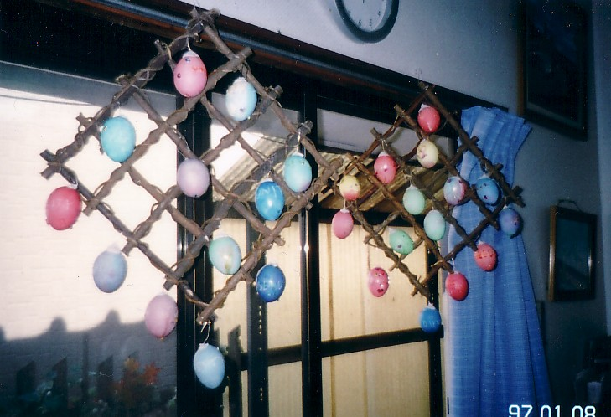
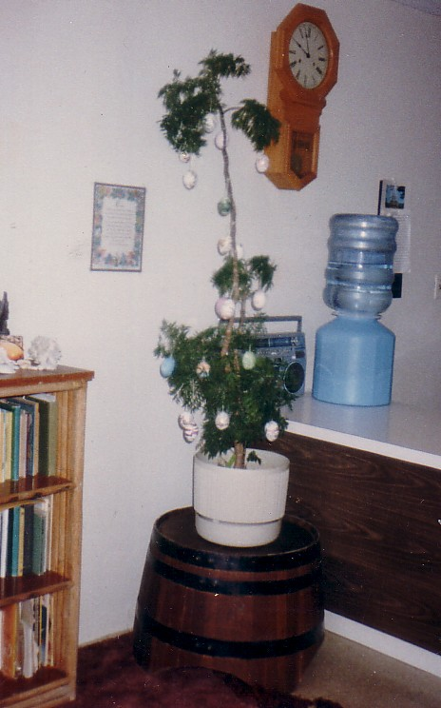

Parent’s Page
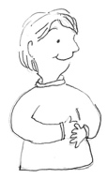
Parents Page
Children need a role model. If we don’t show them one, they will find their own, from a movie star, or singer or a friend’s older brother or sister. What better example can we give them than Abdu’l-Baha. The stories and words of Abdu’l-Baha teach all of us how to be happy and loving people. There are books such as Vignettes from the Life of Abdu’l-Baha or the Chosen Highway and others that have some of these stories.
In the Baha’i Children’s classes, the children can also hear many stories. Below is a list of the Baha’i Children’s Classes through out Japan. Parents are also invited to join Study Circles that are offered in most communities in Japan.
Tohoku: Donna Mandeville 022-234-1054mandeville_sen@ybb.ne.jp
Kanto : Ryo Lumsden 042-724-2209 mikipooch1@gol.com
Kansai/Chubu : Masumi Spann 0774-65-2297 mspann@theflyingpig.com
Shikoku : Hiroko Ando 087-823-7214 ando-777@ad.cyberhome.ne.jp
West Chugoku : Marilyn Higgins 083-922-9822 mhiggins@c-able.ne.jp
Northern Kyushu : Michiko Hata 092-926-3756 mhata@rmail.plala.or.jp
Kumamoto: Luana Hirahara 096-235-6165 vb7mb7@bma.biglobe.ne.jp
Okinawa ; Seiko Enoki 098-886-0291 naranponny@kind.ocn.ne.jp
“As to thy question regarding the education of children; it behooveth thee to nurture them at the breast of the love of God, and urge them onward to the things of the spirit, that they ay turn their faces unto God; that their ways may conform to the rules of good conduct and their character be second to none; that they make their own all the graces and praiseworthy qualities of humankind; acquire a sound knowledge of the various branches of learning, so that from the very beginning of life they may become spiritual beings, dwellers in the Kingdom , enamored of the sweet breaths of holiness, and may receive an education religious spiritual, and of the Heavenly Realm.”
~Abdu'l-Baha
Virtues):Love, Justice, Honesty, Courtesy, Reverence, Obedience, Truthfulness,Kindness,Unity,Humility,Selflessness,Purity,Cleanliness,
Peacefulness, Courage, Patience, Love, Forgiveness, Mercy, Compassion.
Answers to the quiz on Page 9
1)We all do; 2)Baha’u’llah; 3)Japan; 4)Fujita san; 5)There was a great power that if discovered too soon, could destroy the world; 6) Be glad and show them kindness seeing them as different colored flowers; 7)Care for them as we would one of our own family; 8)the Ark is like the new teachings from God; 9)the bad people were like unicorns.
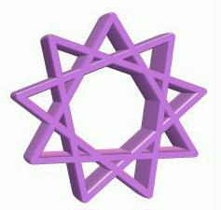

Hiru no Hoshi
If you have stories of your children learning a virtue or anything connected to the Faith, please send them to us, so we can have stories of “A little boy in Yamaguchi” or “A little girl in Akita”. You can either write the story yourself or send the details and we will write the story. Either English or Japanese is fine. We also are waiting for pictures of Children’s Classes from your community, or drawings from your children. Please send all stories and pictures to hirunohoshi@gmail.com or vb7mb7@bma.biglobe.ne.jp
The National Spiritual Assembly of the Bahá’ ís of Japan
13-2-7 Shinjuku, Shinjuku-ku, Tokyo-to
160-0022
Tel. 03-3209-7521 Fax 03-3204-0773

Published: / March 2008
No. 233
Hiru no Hoshi Committee: Rie Mactier, Seishi Hirahara, Luana Hirahara
Contributors:
Translators; Kazuko Bray, Rie Mactier, Seishi Hirahara, Asma Hirahara
Photographs:,Jana, Luana Hirahara,
Drawings: Larry Curtis, Noriko Ishikawa, Daryl Maude; Kayoko Hainsworth; Bridgette Schnider
Technical Advisor: Nicholas Mayor
Supervisor: Yuichi Hirano

